**UI PATH SELECTORS**

**What are selectors?**

A selector is basically a plaintext that is used to find a particular UI element among the running application.

Eg:

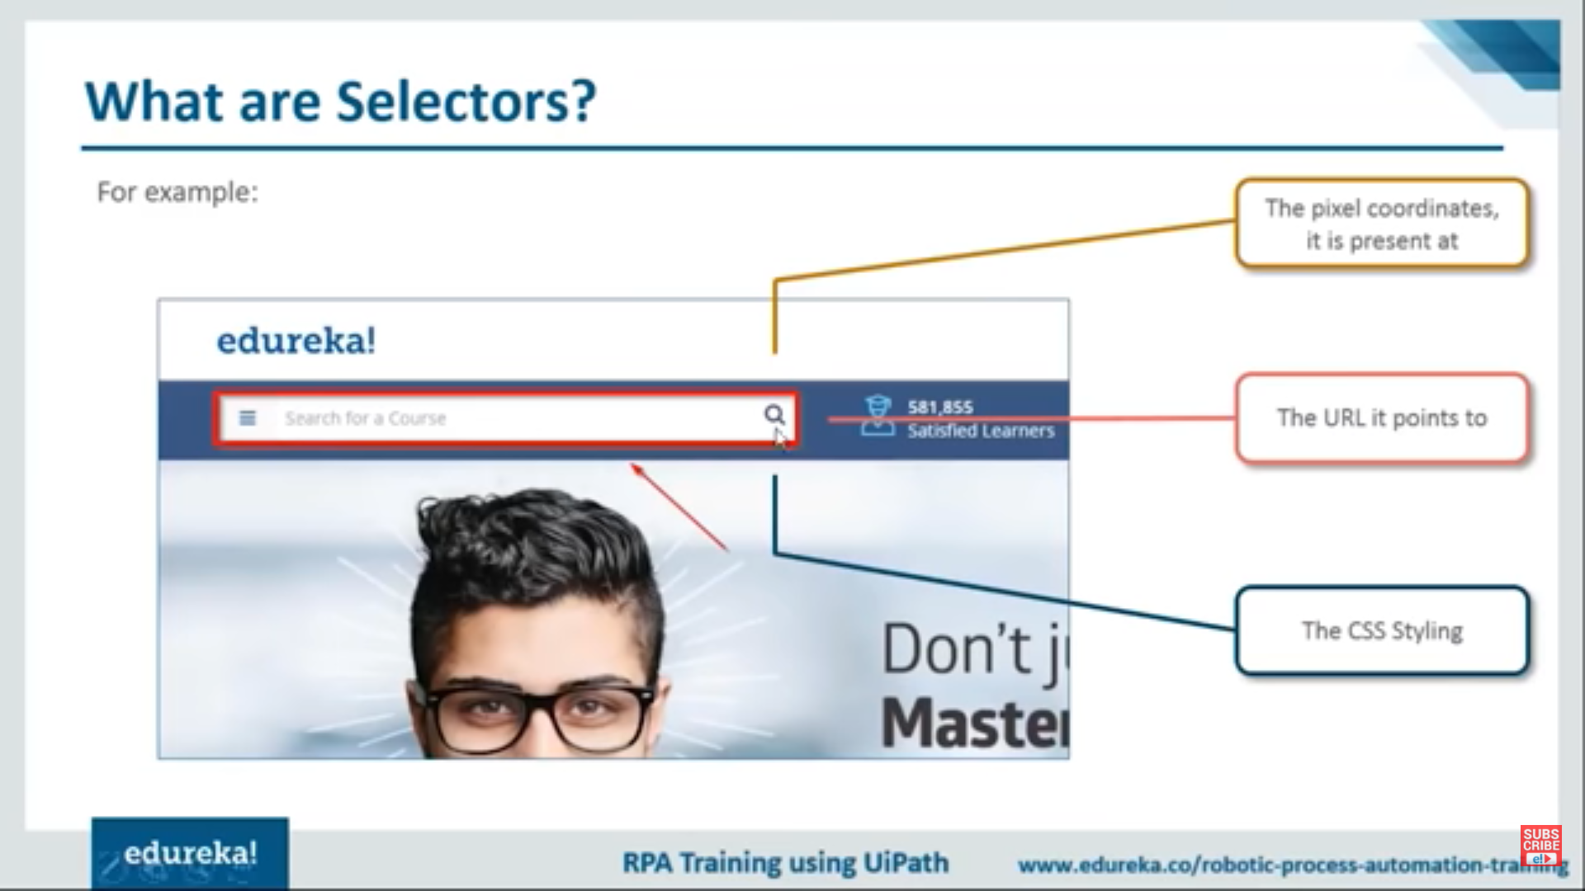

**Why do we need selector in UIPATH?**

We use selectors whenever we want to templatize the objects we want to be automate.

Eg:

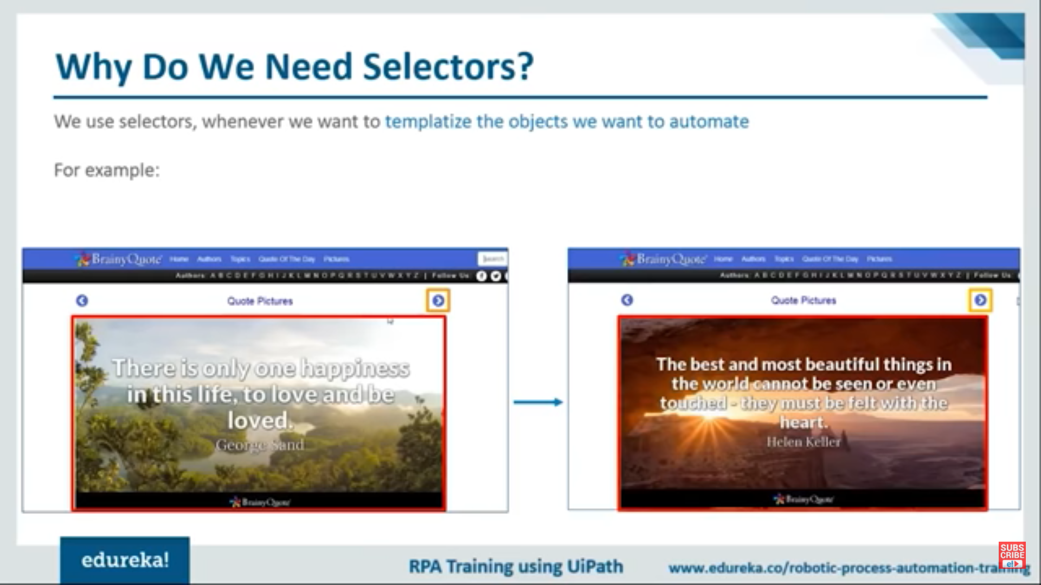

**How to use selectors in UIPATH?**

This is the tool,that you will be using to leverage the power of selectors in uipath. The tool is **launch Ui explorer selectors.**

**Hands-on**

Create an automation process where you will ask the user the number of image he want to save and automate.

**How to run project in UIPATH?**

* Create a new blank project
* Search sequence drag and drop down
* Search open browser drag and drop down
* Search take screenshot drag and drop down
* Search click drag and drop down
* Search input dialogue box drag and drop down(enter name, description, and result)
* search save image drag and drop under the screenshot activity,set the result value in the screenshot activity(cntrl+k)
* Set the path in the save image activity(in this case we create a new folder to save the images)
* Search do while drag and drop, add variable name and add the condition is **val<CInt(num)**
* The all searching activities are copying to the do condition.thesse copying activities are again drag and drop under the open browser activity
* Search delay drag and drop,then set the time
* Search assign value val=val+1
* Finally run the project.